ABOUT THE HARDWARE

WE Used RASPBERRY PI MODEL 3B+ Along With ARPI600 to convert data from analog to digital value

Since raspberry pi cant easily analog values

Steps For Hardware Connections

1.)First ARPI 600 Is installed on Raspberry pio.All the 40 pins of Raspberry pi gets connected to 40 pins of ARPI 600

2) GND Of Sensor -> GND of Arpi600

VCC of MQ-135 sensor->3.3V of ARPI600

A0 of MQ-135 Sensor->T_A6 of ARPI600

D0 of MQ-135 sensor->P0 of ARPI600

3)FOR Setting I2C control Pins

We Connect A4 TO P_SCA and A5 TO P_SDA

Schematic Diagram

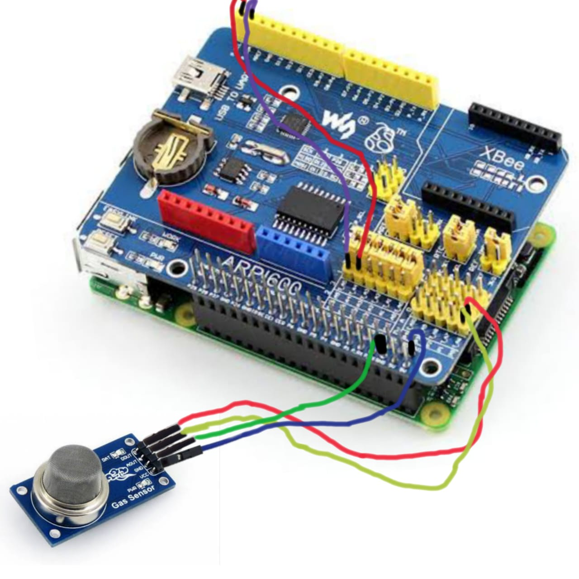

Practical Diagram Before And After Giving Power Supply

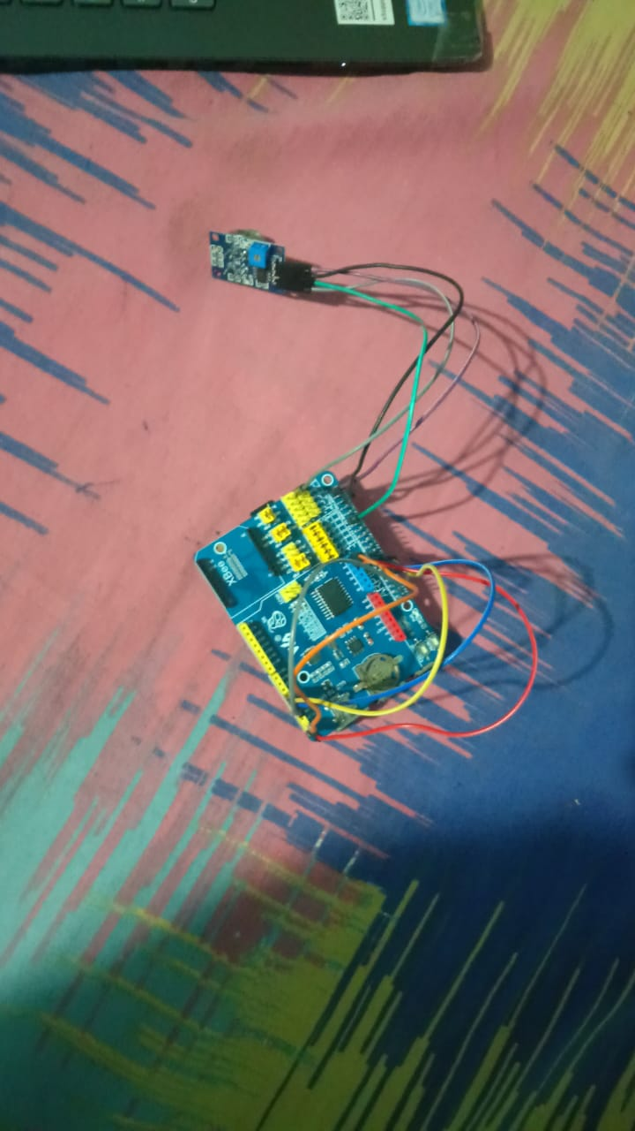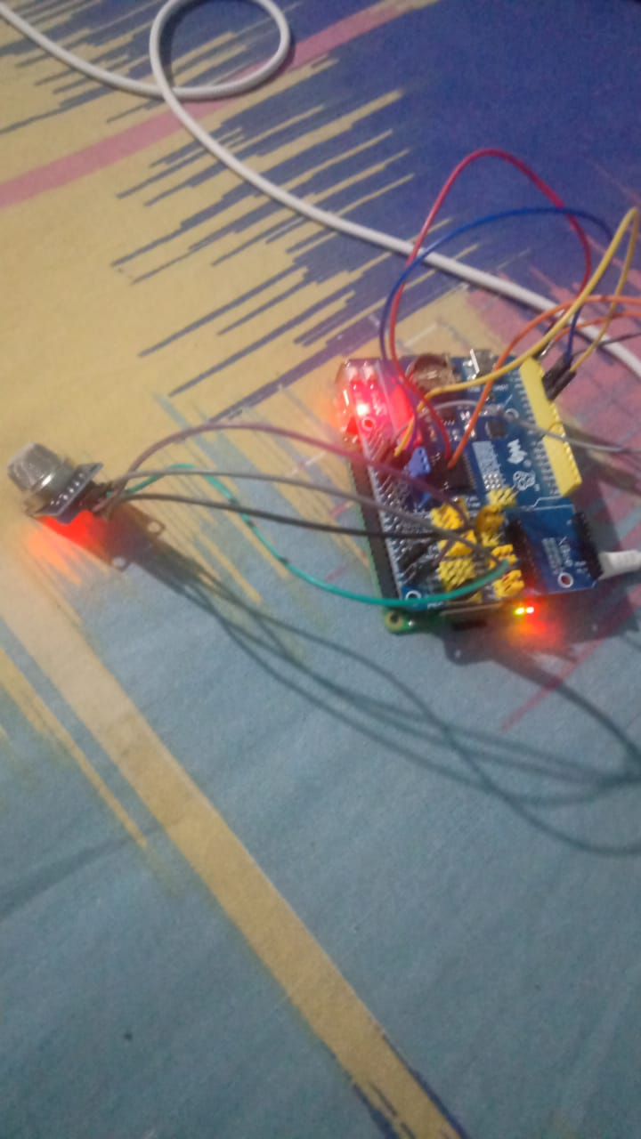

After Power supply is given Sensor shows light that means it is now on

Sofware Part Of Raspberry pi

First Raspbian OS is set up in SD card using etcher

That SD card is then put into Raspberry pi

Raspberry pi was then installed and wifi connection was made using SSH

Using Vnc viewer and knowing the IP address of the Raspberry pi we set up the raspberry pi OS in our desktop

Then the codes for getting data and uploading of the data was done in our pyrebase

For running the codes Linux commands were used

Chmod +x MQ_135-Gas_Sensors.c

Sudo MQ-135_Gas_Sesnors.c